Website Specifications
1. Purpose of the Website
The purpose of the website is to allow users to:
- Browse available rental cars
- View car details (price, model)
- Make bookings online
- Choose their desired service
- Contact the company for support
The website will serve as an online platform to promote and manage a car rental business.

2. Target Audience
- Individuals aged 18+ with a valid driver’s license
- Tourists visiting the area
- Business professionals needing temporary transport
- Local residents needing short-term vehicle use

3. Functional Requirements
The website must include the following features:
- User Registration & Login
  - Users can create accounts and log in securely
- Car Listings Page
  - Display available cars with images, prices, and descriptions
- Search & Filter Function
  - Filter cars by:
    - Price
    - Car type (SUV, sedan, etc.)
    - Availability
- Booking System
  - Users can:
    - Select rental dates
    - Choose a car
    - Confirm booking
- Contact Form
  - Users can send inquiries or complaints
- Navigation Bar
  - Easy access to all pages

4. Non-Functional Requirements
- Website must load quickly (under 3 seconds)
- Mobile-friendly (responsive design)
- Easy to use (user-friendly interface)
- Secure handling of user data
- Available 24/7

5. Hardware Requirements
For Developers:
- Computer/laptop
- Internet connection
For Users:
- Smartphone, tablet, or computer
- Web browser (Chrome, Edge, Safari, etc.)

6. Software Requirements
- Web browser
- Code editor (e.g., VS Code)
- Programming languages:
  - HTML
  - CSS
  - JavaScript
Optional:
- Backend (if advanced): PHP / Node.js
- Database: MySQL

7. Website Structure (Site Map)
- Home Page
- About Us Page
- Car Listings Page
- Booking Page
- Contact Page

8. Input Requirements
- User details (name, email, phone number)
- Booking dates
- Selected car

9. Output Requirements
- Booking confirmation message
- Display of available cars
- Contact form submission confirmation

10. Constraints
- Time constraints
- Internet access required
- Basic security implementation only

11. Success Criteria
The website will be successful if:
- Users can easily navigate the site
- Bookings can be completed without errors
- Pages load quickly
- Design is visually appealing

Wire frames
DESKTOP
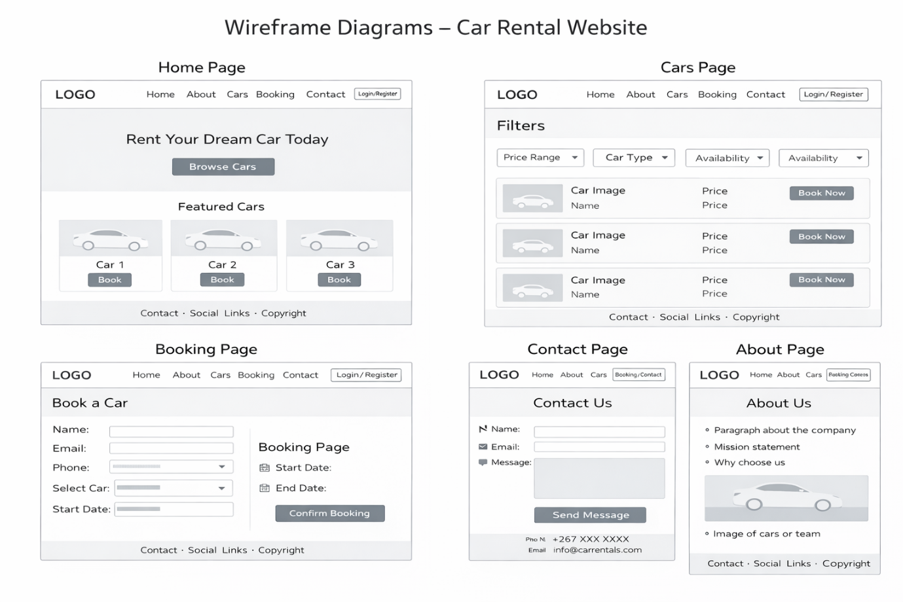

MOBILE
